Digital Literacy Skills:
Training Program for Volunteer Managers

Course Outline:

1 | Introduction to Digital Skills
2 | Toolbox
3 | Microsoft 101
4 | Google 101
5 | Email Effectiveness
6 | Guide to Online Meetings
7 | Guide to Delivering Webinars
8 | Digital Marketing Fundamentals
9 | Digital Marketing
10 | Social Media Strategy – Part 1
11 | Social Media Strategy – Part 2
12 | Website 101
13 | Design Basics
14 | Cyber Security

Introduction to Digital Skills
Objectives: To understand why digital skills are important, and for Volunteer Managers to gain foundational digital skills on topics such as internet basics, browsers, search, accounts, sharing and connecting online, and online safety.

Video Script: Module 1

“Welcome to Introduction to Digital Skills!

Now –– what are digital skills, exactly?

Simply put, digital skills are the abilities required to use digital technology, such as computers and smartphones, in a smart, safe, and successful way.

Think of digital skills less as new, foreign skills you have to learn and more like a continuation of the skills you already have!

You have communication skills, right? You know how to talk with your friends, family, and colleagues. You see, technology only furthers our ability to communicate with each other. Digital skills build on this. We're simply learning how to take our communication skills and translate them to the online world, so you can email, chat, and connect with your community, wherever you are.

You also know how to scan through books and research to find an answer. Searching for an answer on the internet is quite similar, yet faster, and with limitless information available at your fingertips! It's the same concept, just with a different method that makes it easier to learn, discover, and create opportunities. We’re here to help you learn this method!

We’ve been evolving into this “digital world” for quite some time now. But since the COVID-19 pandemic, we’ve leapt even further into an online existence. You can grocery shop, chat with your friends, and even work full-time from your phone or computer.

Digital skills aren’t just a bonus, but a requirement. Today, 87% of jobs require employees to have digital skills! Unfortunately, these skills aren’t equally accessible to everyone. There’s a severe gap in digital skills in Australia.

In 2020, over 50,000 Australians reported that a lack of digital skills or digital skills education were the main reasons they couldn’t find a job. And many who already had a job felt as if they didn’t have the digital skills needed to keep up. Most of those felt that they simply didn’t have the time or funds to gain these skills. Even for entry-level positions, employers now require skills such as email communication, online research, information security, collaboration tools, spreadsheet and document management, handling devices, video calls, and online calendar and productivity understanding.

This is just at a basic level. Most advanced or high-paying positions require specialised knowledge in additional software and online tools.

This is why we’re going to build your digital skills. Personally, digital skills can help make your life easier and enable you to feel more connected. But professionally, they can open up job opportunities, and expand the range of what you can do. We’re here to make these skills simple and accessible to everyone, starting with you!

It’s important to know these opportunities, as well as the foundational rules and hazards.

For example, using email, chat, and social media will enable you to communicate and connect with others, but you must know how to properly use them to do so. Search engines and websites can provide you with a wealth of information: you can easily find answers through Google searches, Frequently Asked Question Pages, written and video tutorials, chatbots, software, and productivity tools –– but once you find these answers, you must also be able to decipher whether the information you’ve found is legitimate or not.

Technology allows us to make purchases online, helping us save time – and even money – in some cases. Of course, you must know how to set up these online accounts and forms and ensure your payment method is secure so you can protect your valuable assets and information. If you’re not careful, your passwords and payment information can become compromised, and your identity or money can be stolen.

But don’t worry: Just a bit of online safety knowledge and digital skills can help protect against this.

Once you know even the basics, you can create opportunities, save time, and learn more than ever before. And by doing so, you can help others! To start, we’ll go over the basics of digital skills in the reading portion of this Module. From internet basics and browsers to online safety and sharing, we’ll break down some of the foundational skills and knowledge needed to feel comfortable and confident online. See you there!”

Reading Portion:

Module 1
Internet Basics

Welcome to Introduction to Digital Skills! Let's start with the basics. We'll break down how to connect to the internet, use browsers, search for information, set up online accounts, communicate online, and protect yourself and your information.

Ready to get started? Great!

Connecting to the Internet

Devices –– such as phones, computers, laptops, and tablets –– need to be connected to the internet before you can use them to go online and visit a website. This requires you to connect with Wi-Fi or mobile internet. You'll usually set this up at home with an internet service provider or mobile phone company.

What is Wi-Fi?

Wi-Fi networks enable multiple devices to access the internet wirelessly, simply by logging in with a password. You'll set up your own network name and password with your internet provider at home. Once you're logged in, you should remain logged in, unless you disconnect your internet.

What is Mobile Internet?

When you leave your home, you can still access the internet if you pay for internet on your device (mobile phone or iPad). If you pay for internet on your phone or other devices, you won't necessarily need Wi-Fi, but connecting to Wi-Fi will save you in data costs and can help to increase your internet speed.

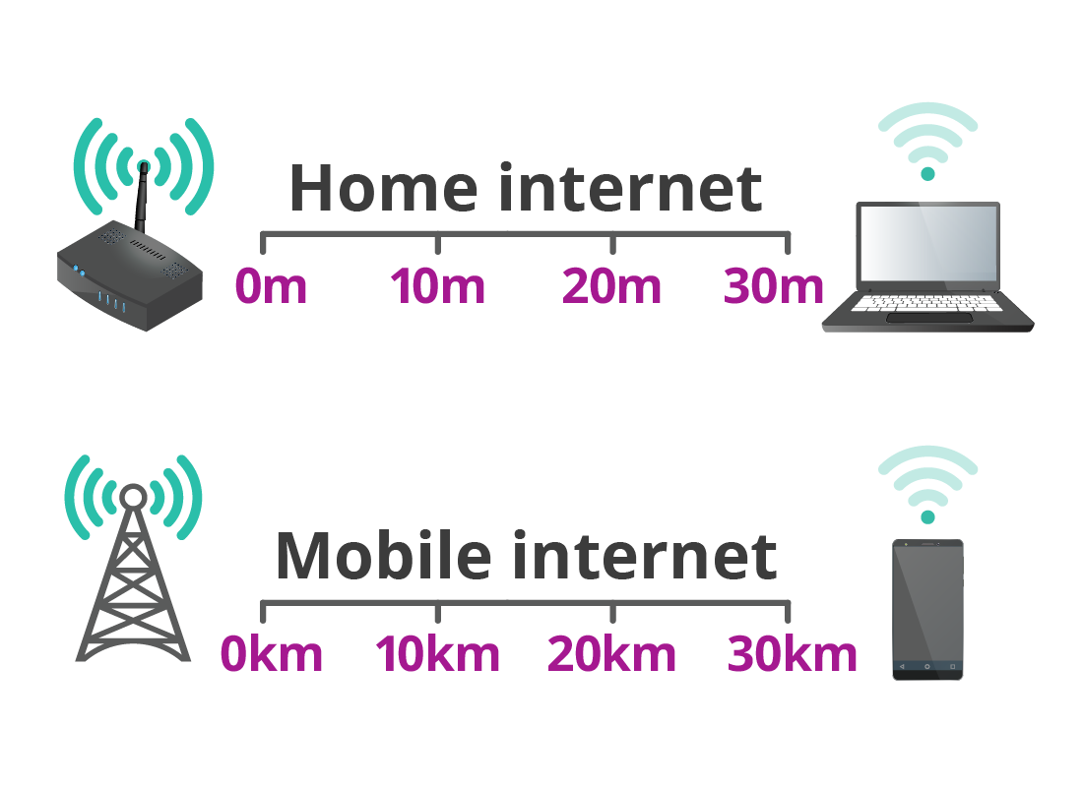
Accessing the Internet Outside of Your Home

If you leave your house – or you do not have internet access in your home – you may be able to go to a library, internet cafe, coffee shop, or university that offers free Wi-Fi access. The National Library, State Libraries, and most local libraries offer free Wi-Fi access, as well.

If you want to connect your device at one of these locations, go into your device's settings, and select "Wi-Fi. Click on the location’s network name, and type in their password. You can always ask an attendant or employee at the site if they have free Wi-Fi access and, if so, what the network password is.

Browsers

Once you're connected to the internet, you'll need a browser to open it. Browsers are simply programs that allow you to use search engines and access websites. Think of a browser as your front door to the internet!

There are a few main browsers you can choose from:

 | - Google Chrome
 | - Apple Safari
 | - Microsoft Edge
 | - Mozilla Firefox

Each programme gets the same job done. However, if you use an Apple device – such as a Mac, MacBook, iPhone, or iPad – Apple Safari will automatically come with it.

The same goes with Google Chrome if you have a Google device, and Microsoft Edge if you have a Microsoft device. If you prefer one over the other, you can always download it for free on any device. (We’ll go over different types of devices and tools in our next Module!)

Put simply, every computer and the digital device should already have a default browser installed. To use it, you'll simply click on your browser's icon – then, you’re online!

Search

Finding Answers

Once you’ve connected to the internet and opened your browser, the options are endless! Most often, you’re going to start with a search engine. Google is the most popular search engine, but you can also use others such as Bing, DuckDuckGo, and Yahoo.

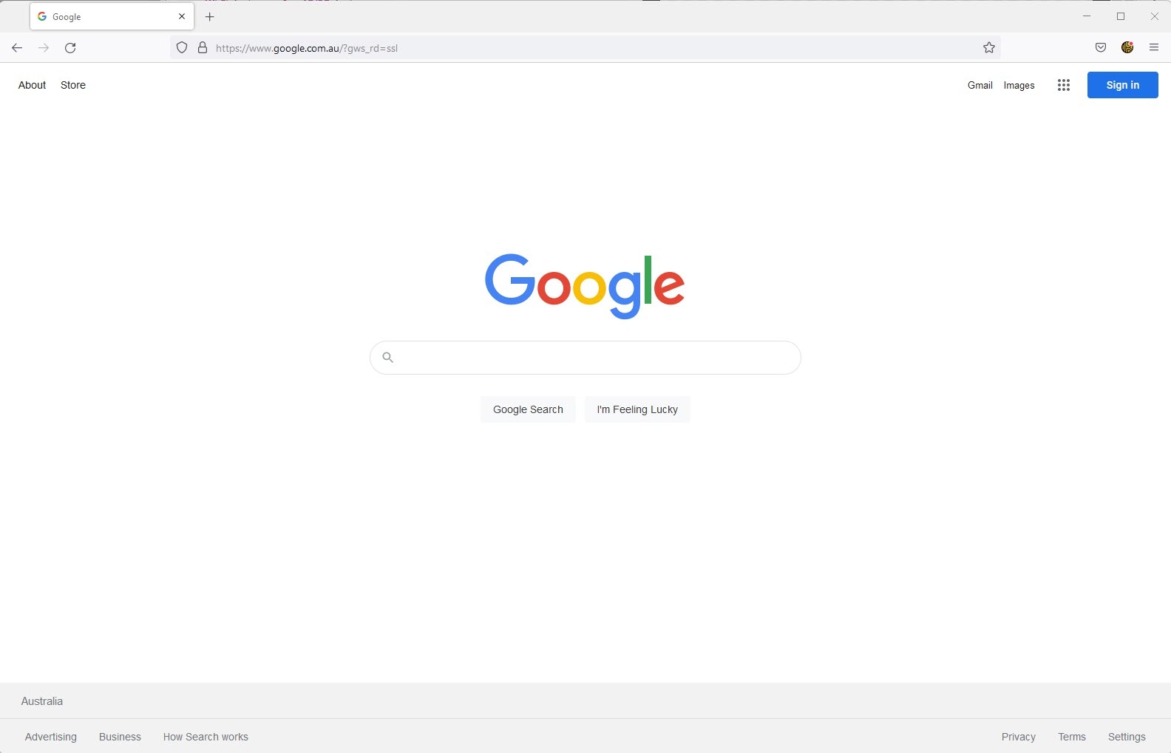

Depending on your browser, you might be automatically directed to Google search.

Here, you can find websites, answers to questions, and solutions to problems.

If you’re looking for specific information, there are a few main routes to achieve this:

- Type a short summary of your question in the search engine bar.
- Visit the FAQ pages on websites. This stands for “Frequently Asked Questions.” This can help you find answers to common questions.
- Search for tutorials. For example, you could type in “Google Doc tutorial” into the search engine bar. You’d find results for articles and videos you can read or watch to learn. The options are truly endless!

Are They the Right Answer?

You can find endless answers and solutions on the internet. But not all of them are the right answer.

If you type in “Best Browser,” you’ll get a mix of research and opinions. Many websites, articles, and videos are advertisements, meaning they’re not just trying to inform you on a topic, but they’re also trying to sell you a product. This isn’t inherently bad – but knowing this can ensure you maintain a healthy scepticism and better understand what information is true or untrue online, which is known as media literacy.

Know that not all information you find online is reliable. Not all websites are trustworthy, so be careful before sharing any personal information or making any purchases online.

Best Practices for Media Literacy:

- Cross-check your information.
Most often, the top results on an online search are the most reliable. If you’re looking for an answer to a question, read multiple articles or watch multiple videos to see if the facts stay the same. If the information doesn’t add up, keep looking.

- Look for credible sources.
Look to see if the information comes from a legitimate source, like a not-for-profit, government, or credible business website, rather than an unknown or unprofessional web page.

- Check if a website is legitimate.
If you’re unsure whether a website is legitimate, search its name and see what else comes up.

Online Accounts

You’ll find that many websites and applications require you to set up an online account to start using them, as you did with your Google account.

Why Do You Need Online Accounts?

Online accounts make it so that your information is secure. If you're the only one who knows your username and password for your online bank or Facebook account, it’s difficult for others to access them. This is the goal! We don’t want anyone logging into your online accounts and taking information or money.

Setting up Online Accounts

Most of the time, there is no charge to create an online account. For example, you can sign up for a free Amazon account, but you’ll need to connect your secure payment method to make purchases.

Most online accounts require a few basic details to set up: Your name, email address, date of birth, and sometimes, your phone number. You’ll need to create a secure username and password to sign in from here. We’ll go over tips for safe passwords later. For now, be sure to choose a unique login that only you will know and remember.

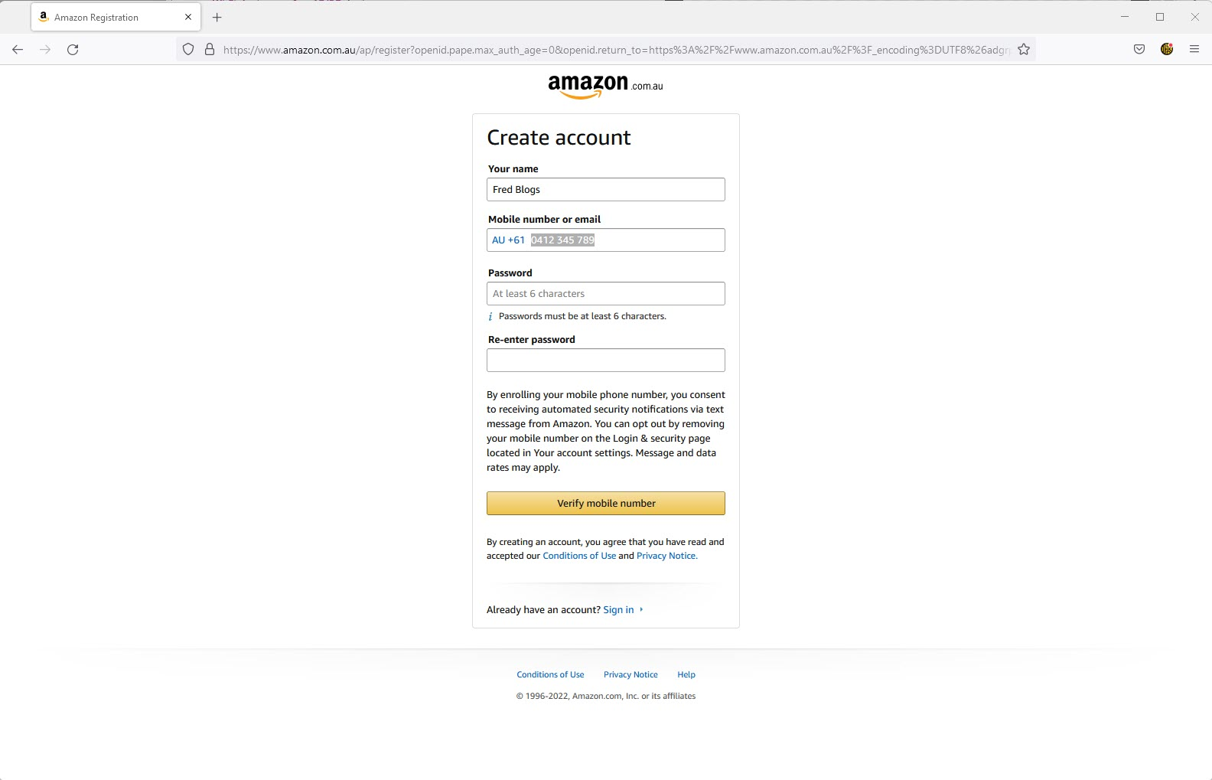

Setting Up Secure Payment Methods

Some websites will need more details, such as your billing address and credit or debit card number. You should never have to share this information if you’re not planning on making any purchases on the website. You should also never have to provide sensitive information such as your Tax File Number, race/ethnicity, political opinions, religious affiliations, or health records. Think about the information you give in-person stores to make a purchase – they don't need sensitive data to process your transaction!

Be extremely careful before giving any information to a website. Only fill out secure online forms you accessed while logged into your account. If someone sends you a link to a form or asks for this information, do not give it to them!

You can double-check if the form is a secure payment method:

- Check for a secure connection.
Verify that your Wi-Fi is secure. To the left of the website link at the top, there should be an icon that looks like a padlock. If this icon is locked, the website should be secure. It should look somewhat like this: 🔒

If it isn’t secure, it should appear unlocked or have some sort of red ‘x’ or signal around it indicating that it’s insecure.

- Only use websites you’re familiar with.
Try to only make purchases on credible websites you’re familiar with.

- Use secure payment platforms.
Platforms such as PayPal, Authorize.net, Stripe, or Square are trusted and secure.

- Use credit cards, not debit cards.
Credit cards are much easier to cancel and catch scams with than debit cards.

- Look for an email confirmation.
Once you make a purchase, the website should send you an email confirming your purchase.

- Keep tabs on your bank account.
After making a purchase online, pay close attention to your credit card/bank account activity.

Sharing and Connecting Online

One of the best aspects of the internet is that it makes the world seem smaller. Thanks to social media, email, and other communication tools, we can instantly call, message, or even video chat with a click of a button!

However, when sharing and connecting online, there are a few things to keep in mind to ensure your identity and interactions are safe and secure.

Email

You’ll need to create an online email account to send and receive emails. Options for this include Gmail, Outlook, Yahoo! Mail, and Apple Mail. Once you log into your email account, you can view and send emails.

- Typically, your email account will have a “Compose” or “New” button for you to draft new email messages. If you want to reply to an email, then click on the email you want to respond to and navigate the “Reply” button.
- Avoid sending sensitive information over emails.
- Proofread your emails before sending. Make sure you’re sending it to the right email address, include the right information in the text, and provide any attachments (like images or documents) you intend to send.

Using Attachments

Email is popular for sharing documents, images, and other files, especially for work. This process will vary slightly depending on which email platform you’re using. But overall, you can attach files by finding the “paperclip” icon on your email draft. From there, you can select and upload files saved on your computer.

Social Media

You’ll need an email account to sign up for social media, whether Facebook or Instagram or TikTok. These accounts and platforms are separate from each other.

- Choose a username that resembles or includes your first and/or last name.
- Choose a unique password for your accounts.
- You may have to include information about your identity when signing up for your account. However, never share or post this information on your social media account. What you post is shared publicly on the internet.
- Opt for a private social media account. This makes it so that only those you accept friend or follow requests from can view your profile.
- Only accept friend or follow requests from people you know.

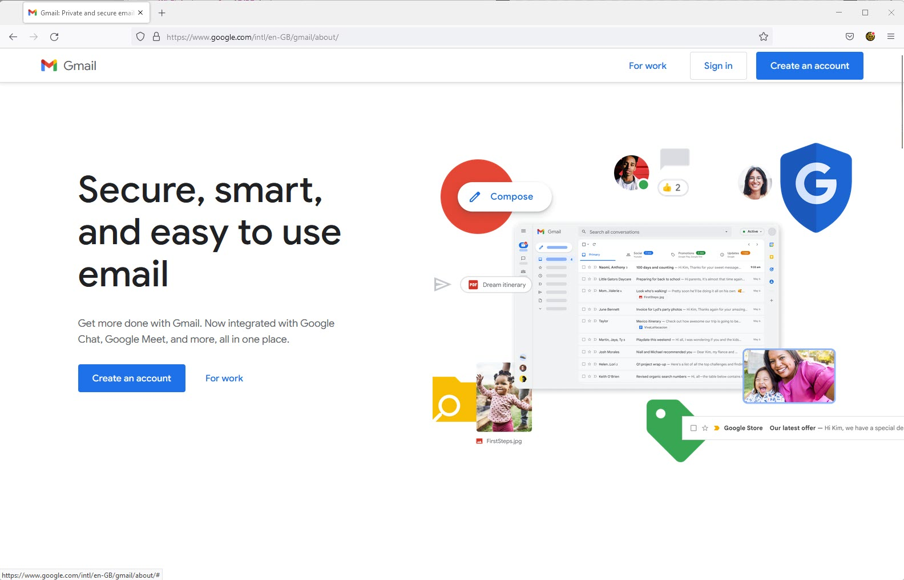

Online Safety

So far, we’ve learned the importance of media literacy and how to find if the information we’re consuming online is credible. We’ve touched on how to set up online accounts safely and determine whether a payment method is secure. We know what sensitive information is and how, 99% of the time, it doesn’t need to be shared online.

To strengthen your online safety, here are a few more tips to keep in mind:

Updating and Keeping Passwords Secure

- Try to use a unique password for every online account. However, you do need to be able to remember these passwords. If you’re using Google Chrome as your browser, you can use Google Password Manager to store and save them.
- Make a habit of updating and changing your passwords regularly.
- Use a combination of uppercase and lowercase letters, numbers, and special characters.
- Don’t use passwords anyone can easily guess, like phrases that include your name.
- Don’t share your passwords or login information with anyone!

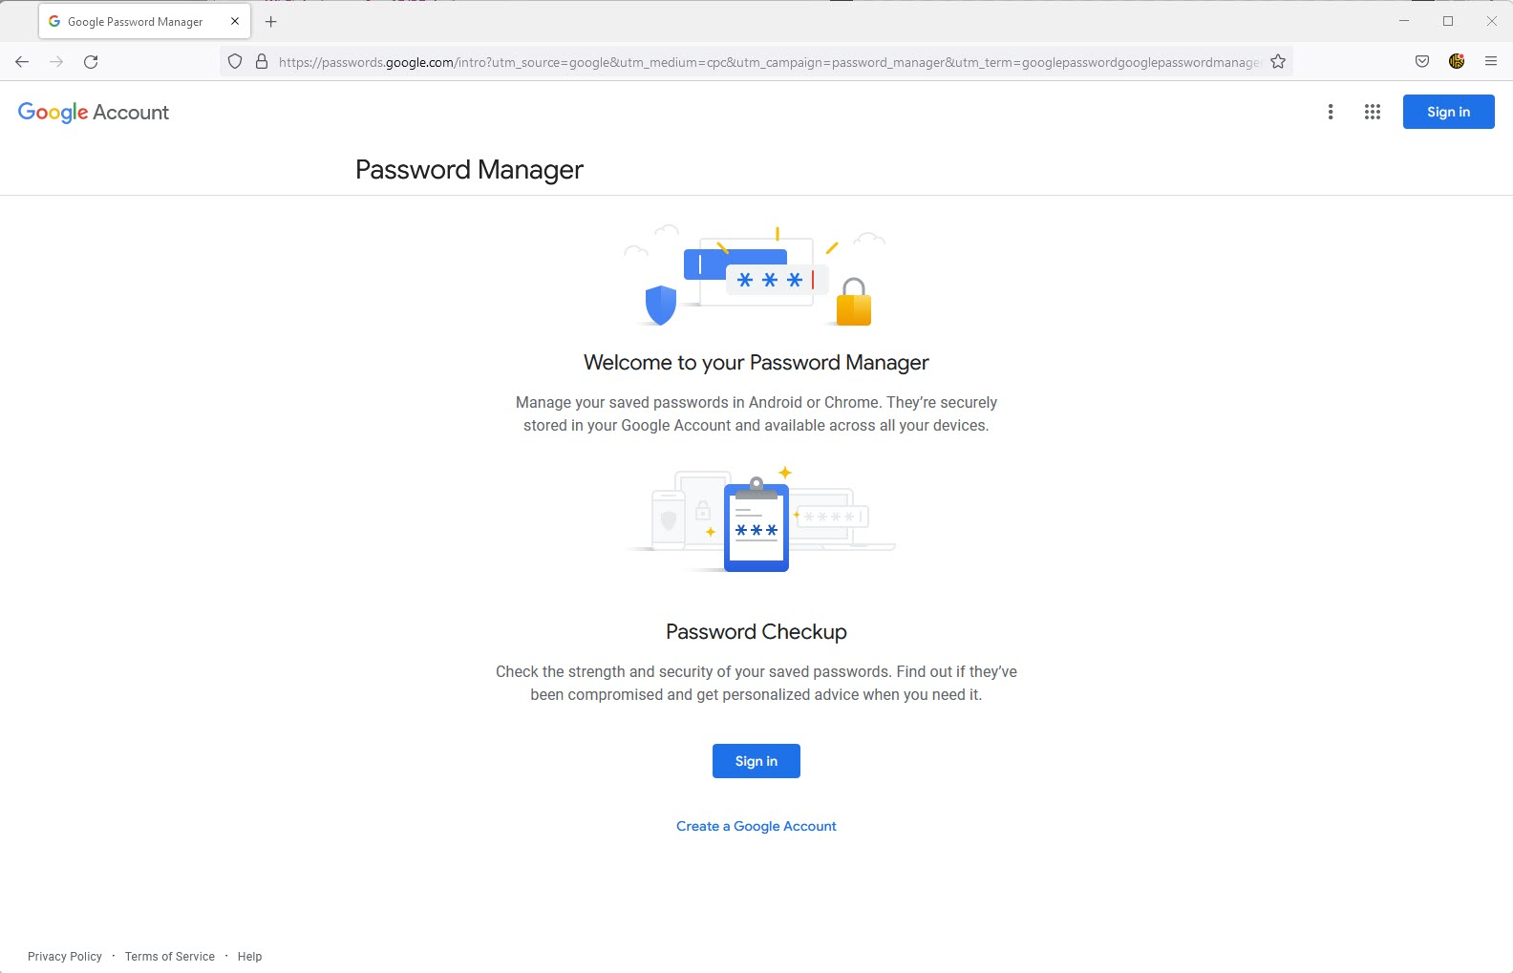

Precautions Against Viruses

Just as our bodies can get viruses, so can our computers! In this case, a computer virus is a malicious software that damages or steals information from your computer.

You can protect your computer from viruses by:

- Opting for a device with built-in antivirus protection (like Apple computers do).
- Downloading a trusted antivirus software (like Norton).
- Not clicking on pop-up advertisements.
- Being careful of opening email attachments you are unsure about.
- Letting your computer scan files before downloading.

