**Digital Literacy Skills:**

Training Program for Volunteer Managers

*Course Outline:*

|  |  |
| --- | --- |
| 1 | **Introduction to Digital Skills** |
| 2 | **Toolbox** |
| 3 | **Microsoft 101** |
| 4 | **Google 101** |
| 5 | **Email Effectiveness** |
| 6 | **Guide to Online Meetings** |
| 7 | **Guide to Delivering Webinars** |
| 8 | **Digital Marketing Fundamentals** |
| 9 | **Digital Marketing** |
| 10 | **Social Media Strategy – Part 1** |
| 11 | **Social Media Strategy – Part 2** |
| 12 | **Website 101** |
| 13 | **Design Basics** |
| 14 | **Cyber Security** |

**Guide to Delivering Webinars**

*Objective: To help Volunteer Managers prepare and deliver engaging remote learning experiences and understand what software to consider.*

**Video Script:**

“Alright, Volunteer Managers! We are going to explore a very important type of communication technology that has changed the way in which we gain knowledge in modern society. By the end of this module, you’ll be able to confidently and safely use technology to develop and deliver webinars and learning sessions online!

Have you ever used FaceTime, Zoom, or Skype to video chat with your friends, family, or colleagues? They are all similar to webinars. So, think of conducting a webinar presentation as if you’re delivering a learning session over video chat.

A webinar –– short for web seminar –– is an online educational presentation. It is fully live and interactive, meaning you'll be addressing your webinar participants in real-time. They’ll be able to ask and submit questions throughout! Think of a webinar as a live video call in which you're also able to share a visual presentation with the participants, to support their learning session.

Many teachers and educators find webinars to be the best way to empower remote-based learners, which is why they are often used in business and educational settings. They enable you to interact with participants live, but also to share videos, photos, slideshows, documents, and more!

Remote learning became common during the COVID-19 pandemic, so rest assured that it’s been tried and tested! Webinars have been proven to be a very accessible way to learn; you speak to participants, with the text and visuals on their screens helping them to read and follow along…

Video chat and webinar software enable you to interact with and present learning sessions with your volunteers or stakeholders for one-to-one or group sessions – you may be teaching one individual or many, all at once! Webinars allow multiple people to tune into a live presentation and interact with your lesson in real-time – perhaps the closest thing to delivering a lesson face-to-face, webinars enable us to reach people across Australia!

However, if you aren't prepared for delivering a webinar, it can be difficult to ensure that your learners pay attention and get the most out of the experience.

But don't worry –– we're here to help you prepare and present with success!

Delivering a webinar is quite simple, once you know what to do and expect. After delivering a few webinars, you'll become a pro! And as a result, you'll engender growth, opportunities, and success throughout the communities you serve.

In this Module, we’ll give you all the tools and tips you need to deliver engaging remote learning experiences! We'll help you understand what you need to consider when choosing the right software for your webinar, and explain how you can keep your volunteers, stakeholders, sponsors, and other learners feeling safe, confident, and empowered throughout their learning sessions.

Stay tuned, Volunteer Managers! Let's learn how to help *others* learn to succeed!"

**Reading Portion:**

**First Things First: What *is* a Webinar?**

Welcome to the foundational Guide to Delivering Webinars! Before we begin, let’s get clear on what a webinar is, and how it works.

A [*webinar*](https://venngage.com/blog/what-is-a-webinar/#2) is a live, interactive online educational presentation. The word ‘webinar’ is short for web seminar, meaning it’s an online lesson. Webinars are often used in business and educational settings for virtual meetings and lessons.

**How Do Webinars Work?**

As a *webinar* *host*, you’ll be conducting online learning sessions using video call software, such as Zoom.

Often, webinars include a visual slideshow presentation, using Google Slides or PowerPoint. This means that the webinar participants can hear and see you, as well as any documents, text, images, videos, and files you want to share with them to support their learning.

In short: Think of webinars as a live video call in which you can also share a visual presentation with participants, to support their learning session.

You can deliver a webinar by inviting participants to join your call session, just as you can with video chatting. Once there, you’ll be able to interact with and talk to participants live. You’ll be able to ‘share your screen,’ to allow webinar participants to see the information on your computer screen while still seeing and hearing you. This information will be your educational presentation –– your learning slideshow to support what you’re teaching!

**How Will You Use Webinars as a Volunteer Manager?**

As a Volunteer Manager, you are the webinar host!

You will use webinars to deliver engaging learning experiences to volunteers or other stakeholders who are unable to attend face-to-face sessions. Remote sessions can either be delivered via telephone or video chat. With video chat, you will be guiding them through a webinar presentation!

We will be taking care of the educational material for you; all you need to do is host the webinar and guide the participants through the session. You’re there to break down the learning concepts, provide confidence and support, and answer any questions. Everything you need to know will be taught in these training sessions!

You can host a webinar by downloading and creating an account with webinar software.

**Choosing the Right Software for Your Webinar**

There are several programs you can use to deliver your webinar. Our main goal is for you to choose a user-friendly software you’re comfortable with, that provides free plans. We want both you and your remote learners to be able to teach and learn, free of charge and free from stress.

With that in mind, you’ll want to choose free, accessible, and beginner-friendly software. You can use video chat platforms to deliver your webinar so that it’s as easy as possible for you.

Some of the most popular platforms with free options include:

* [*Zoom*](https://zoom.us/)

This is the most popular platform for video calls. You can easily use Zoom as a webinar tool – you simply invite participants to join by sharing your meeting link. There are free and paid plans.

Participants can join from their browser or by downloading the Zoom app on their phone or computer. You will need to create a free account to host the meeting and share your link, but participants do not need to. This is a great option for you, as many people are already familiar with Zoom.

* [*Google Meet*](https://meet.google.com/)

Google Meet is another good option for video calls and webinars. It’s another Google tool, such as Google Docs and Google Sheets. It is free, and participants don’t need a Google account to use it. However, as the meeting host, *you* will need a Google account.

You can share your meeting link for participants to join the live video call via mobile device or desktop. Google Meet has a mobile app download option as well.

* [*Microsoft Teams*](https://www.microsoft.com/en-us/microsoft-teams/group-chat-software)

Microsoft Teams is another common video conferencing tool. It works similarly to Zoom, with a free version that enables you to live chat, video call, and share your webinar presentation with participants. Microsoft Teams has a mobile app download option, as well.

You’ll need to create a free Microsoft Teams account to host a session. However, your webinar participants can join your Teams meeting from any device, even if they don’t have a Microsoft account.

Overall, each of these platforms is highly similar in function and format. Regardless of which one you choose, you need to ensure that both you and the webinar participants are comfortable with and have access to the software you choose. Each requires a stable internet connection, a video camera, and a microphone, whether on your phone, tablet, laptop, or computer.

Participants don’t necessarily need a video camera to join the meeting. If this is the case, you will not be able to see them, but they will be able to see you.

One advantage Zoom has over the other two options above is that you can invite a participant to join the virtual meeting using their phone number. If this is the case, they’ll experience the audio of your session, but they won’t be able to see your webinar, and you won’t be able to see them... If this is a one-to-one session, it may be best to schedule a telephone learning session instead.

**Downloading & Creating an Account for Your Webinar Software**

Participants can use their mobile devices to join the webinar. However, as the webinar host, you’ll deliver the presentation from your computer or laptop.

Follow the instructions below to download and set up a free account with each of the webinar software we’ve mentioned:

**Zoom**

*Computers and Laptops*

1. Create a Zoom account [here](https://zoom.us/signup).
2. Download Zoom to your computer [here](https://support.zoom.us/hc/en-us/categories/200101697-Getting-Started-with-Zoom). Select the orange “Download Zoom” button to begin.
   1. *Note: Participants will not need to download this beforehand, as the browser version will automatically download when they join their first session.*

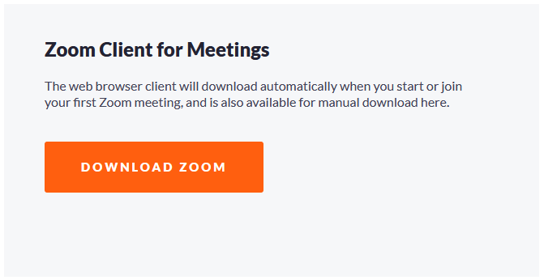

1. The Zoom app will start downloading. Under your computer’s settings, open “Downloads” to find either Zoom.pkg or Zoom.exe.
2. Open this file and follow the instructions on the screen.
3. Once installed, you can open your Zoom app and log in using the account information you set up in Step 1.

*Phones and Tablets*

1. Download the Zoom app in the App Store on your phone.
2. Open it and create an account.

**Google Meet**

*Computers and Laptops*

* Log into your Google Account. Select the menu in the top-right corner and click “Chat.”

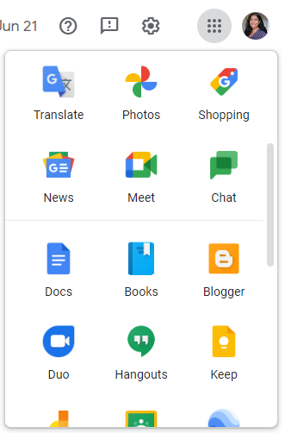

* Alternatively, go to <https://meet.google.com/>

*Phones and Tablets*

1. Download the Google Meet app in the App Store on your phone.
2. Open it and log into your Google account.

**Microsoft Teams**

*Computers and Laptops*

1. Create a free Microsoft account [here](https://signup.microsoft.com/create-account/signup?products=CFQ7TTC0K8P5:0004&lm=deeplink&lmsrc=NeutralHomePageWeb&cmpid=FreemiumSignUpHero-Experiment&tfloptin=true&culture=en-us&country=us&ali=1).
2. Use your login info to sign into Microsoft Teams.

*Phones and Tablets*

1. Create a free Microsoft account [here](https://signup.microsoft.com/create-account/signup?products=CFQ7TTC0K8P5:0004&lm=deeplink&lmsrc=NeutralHomePageWeb&cmpid=FreemiumSignUpHero-Experiment&tfloptin=true&culture=en-us&country=us&ali=1).
2. Download the Microsoft Teams app in the App Store on your phone.
3. Open it and log into your Microsoft account.

**Scheduling Your First Meeting**

Let’s get a bit more comfortable with our webinar platforms. Follow the steps below to schedule your first test meeting:

**Zoom**

1. [Log into your Zoom account](https://support.zoom.us/hc/en-us/articles/360034967471-Getting-started-guide-for-new-users) on your computer or laptop.
2. Select “Meetings.”
3. Click “Schedule a Meeting.”

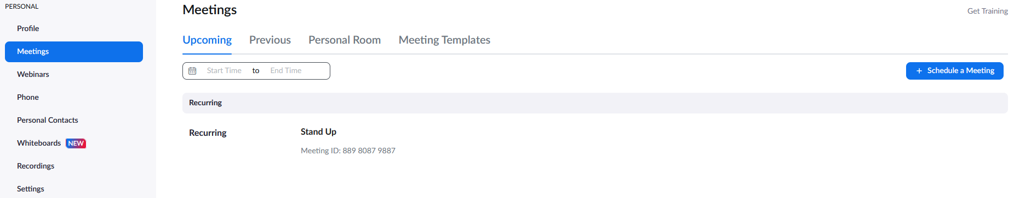

1. Choose the date and time for your meeting and any other optional settings you’d like to adjust.
2. Hit Save.

**Google Meet**

1. Go to Google Meet and select “New Meeting.”

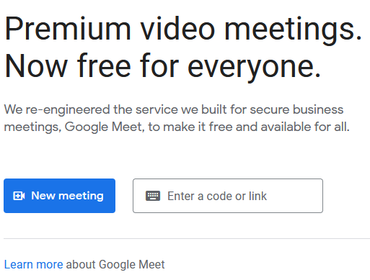

1. From there, you have three options:
   1. Create a meeting for later.
   2. Start an instant meeting.
   3. Schedule a meeting in your Google Calendar.

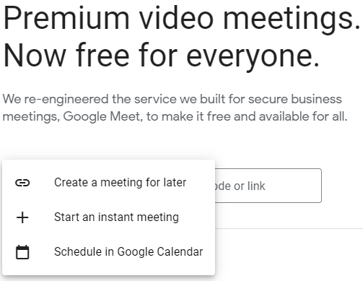

**Microsoft Teams**

1. Log into Microsoft Teams.
2. Select “Calendar” on the left side of the app.
3. Click “New meeting” in the top-right corner.

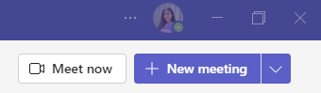

1. Fill out your meeting details.

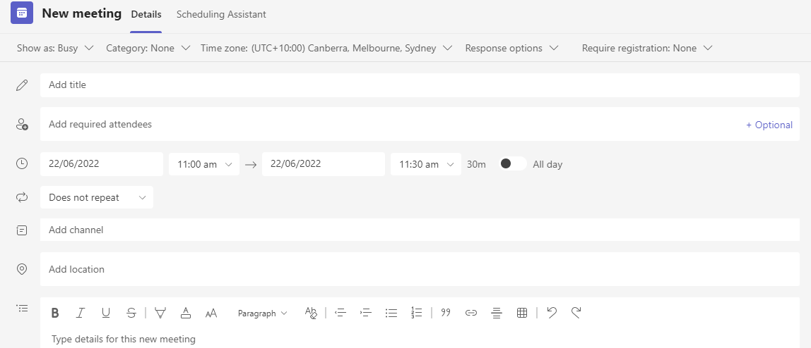

**Inviting Participants to Your Meeting**

It’s time to learn how to invite others to your webinar meeting. In each method, you’ll need to ‘copy and paste’ your meeting link and share it with participants.

You can paste or share the link by selecting the message / text area you want to type it into, navigating the “Edit” bar in the top-left menu bar of your browser, and selecting “Paste.”

**Copy and paste faster with these shortcuts:**

* *Windows Paste shortcut:* To quickly “Paste” the invite link, hold down the ‘control’ button and hit the letter “v.”
* *Mac Paste shortcut:* To quickly “Paste” the invite link, hold down the ‘command’ button on your keyboard and hit the letter “v.”

Now, let’s learn how to find, copy, and paste your virtual meeting link so you can enable participants to join:

**Zoom**

There are a few different ways to do this. The simplest is to share an invite link. Anyone with this link can join your scheduled meeting.

1. Select “Meetings.”
2. Click “Copy Invitation.” This will copy the unique invitation link participants will use to join your meeting when it’s scheduled to begin.

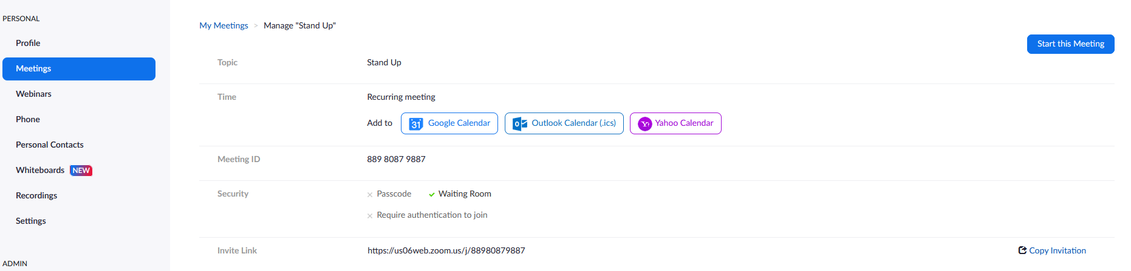

1. You can share this invitation by pasting the link in an email or message to participants.

**Google Meet**

1. Under “New Meeting,” select “Create a meeting for later.”



1. Click the icon next to the meeting link to copy it.
2. Paste and share the link with your participants.
3. Save this link for you to use later, as well.

**Microsoft Teams**

1. Select “[Copy Link](https://support.microsoft.com/en-us/office/schedule-a-meeting-in-teams-943507a9-8583-4c58-b5d2-8ec8265e04e5)” after creating your meeting.
2. Paste it into a message to participants.
3. Save this link for you to use later, as well.

**Preparing for Your Webinar**

You can ensure smooth sailing and successful learning by taking a few moments to prepare for your webinar! Let’s start with preparation on the technical side.

**Starting Your Meeting**

* On **Zoom**, you’ll start your webinar by clicking “Meetings” → “Upcoming” → “Start.”

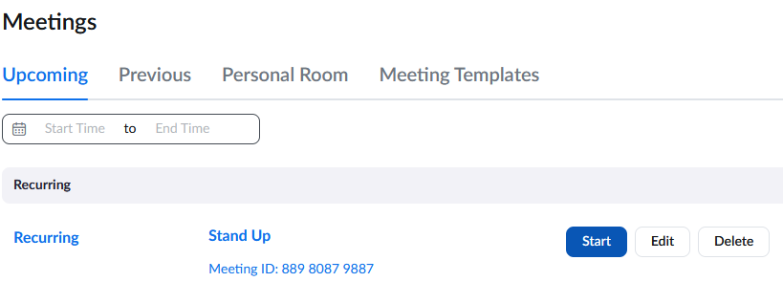

* You'll begin your webinar on **Google Meet** and **Microsoft Teams** by clicking on your meeting link and selecting “Join Now.”

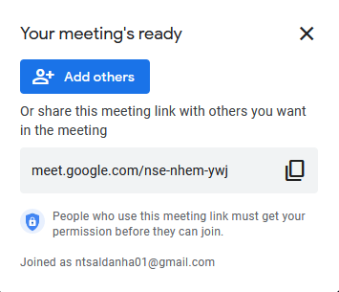

**Checking Your Setup**

You’ll want to log into your meeting early to ensure your computer, internet connection, video camera, and microphone are all working.

On every platform, you’ll see the microphone and video icons. Ensure these are turned on and working. You and the webinar participants can choose to turn off your camera or microphone at any time. You / they will still be in the meeting if you / they do this, you’ll just be hidden or muted. As the host, you’ll want to ensure both are always turned on. You can tell if they’re turned off if they have a cross or ‘x’ in front of the icons.

Double-check that your camera is clean and centred, and your volume is up on your computer so you can hear any participants as they interact.

As you begin your webinar, ask if every participant can hear and see you clearly. Get a direct answer from each participant to ensure you’re good to get started.

**Sharing Your Screen**

During your webinar, you’ll want to be able to share educational materials, such as slideshow presentations, documents, tutorials, and more.

You can do this by sharing your screen. This feature enables your participants to view what’s on your computer screen in real-time. So, if you open your presentation, they’ll be able to see it. Don’t worry –– this won’t log you out of the meeting! You will only leave the session if your internet connection fails or if you actively select the “End Meeting” button (or equivalent).

Follow the instructions below to learn how to share your screen on each software:

**Zoom**

1. Click “Share Screen” on the menu at the bottom of your screen during the meeting.



1. Select the screen you want to share.
2. Click “Share.”
3. To stop sharing your screen, simply select “Stop Share” on the menu bar.

**Google Meet**

1. Click “Present Now” on the menu at the bottom of your screen during the meeting.
2. Select the screen you want to share.

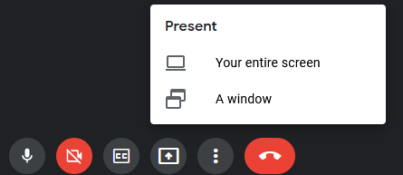

1. Click “Share.”
2. Select “Stop Sharing” on the menu bar to end the presentation.

**Microsoft Teams**

1. Click the “Share Content” button on your meeting’s menu bar.

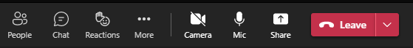

1. Select “Include computer sound.”
2. Select “Stop Sharing” on the menu bar to end the presentation.

**Top Tips for Delivering Learning Sessions Remotely**

You’ve got the tech side covered. Now, let’s focus on the fun part –– engaging with participants and teaching your lesson!

When it comes to [webinars](https://www.11outof11.com/blog/12-tips-for-delivering-a-killer-webinar), there are a few things you can keep in mind to maintain participants’ attention and resonate with them on a personal level:

* **Know your audience.**

Get to know who you’re talking to before you start talking! Gauge their level of understanding of the topics and what their goals are. Don’t be afraid to get to know them as individuals before you start teaching.

* **Know your goal.**

Remember your ‘why’ as a Volunteer Manager. Be inclusive and patient; make sure everyone is following along and engaged throughout by taking it slow and asking questions.

* **Know your material.**

Review what materials you will be teaching participants beforehand. This can help you feel confident and prepared as you ask and answer questions.

* **Join the call early.**

Use the guides above to help you test out and get comfortable with the video chat software. Join the call early to ensure your mic, camera, and internet connection are working. Pull up the educational presentation and any other materials beforehand to share your screen quickly and easily.

* **Adjust your teaching style, based on 1:1 lessons vs. group lessons.**

Teaching one person is different from 2, 4, 7, or 20. Take note of how many people are there, what technology level they’re on, and how you can best deliver each individual session.

* **Have fun!**

Don’t forget to have a bit of fun! We want this to be a positive, empowering experience for both you and your participants. Be kind, patient, and authentic. You make a difference by simply being you!